Name: |  | ___________________________________________________ |  |  |  |  |  | Date: ___________
 |  | Subject :Year 11 Applications  Test 5, 2015  Topics – Linear equations, simultaneous equations, and piece-wise functions. |  |  |  |  |  | 55  = %
Total Time: |  | 60 minutes
Total Reading: |  | 5 minutes
Total Working: |  | 65 minutes
Weighting: |  | 10% of the year.
Equipment: |  | Curriculum Council Formula Sheet; ½ page notes (A4 one side), CAS calculator; Scientific Calculator
SECTION 1: CALCULATOR FREE
Time: |  | 26 minutes |  | Marks for Section 1: |  | 22 marks
Reading: |  | 2 minutes |  | Equipment Allowed: |  | Nil
Working: |  | 24 minutes
1. | [ 6 marks: 1, 1, 1, 1, 1, 1, mark each]  Solve the following equations:
 | - 5x + 3 = 63 |  |  |  | - -7 – 2y = 23
 | - 5h + 13 = 2h – 2 |  |  |  | - 14 – 4d = 27 – d
2. | [ 3 marks: 1, 2]  The cost of hiring a limousine for the year 12 ball is $175 plus $3.50 for each kilometer travelled.
 | - Construct a formula to calculate the cost of hiring a limousine with this company
 | - Calculate the cost of hiring a limousine to travel 36km
3. | [ 6 marks: 1, 1, 2, 2]  Graph the following linear functions on the number plane provided:
 | - x = 5 |  |  |  | - y = ½ x
 | - 2x – 8y = 20 |  |  |  | - 6x – y + 3 = 0
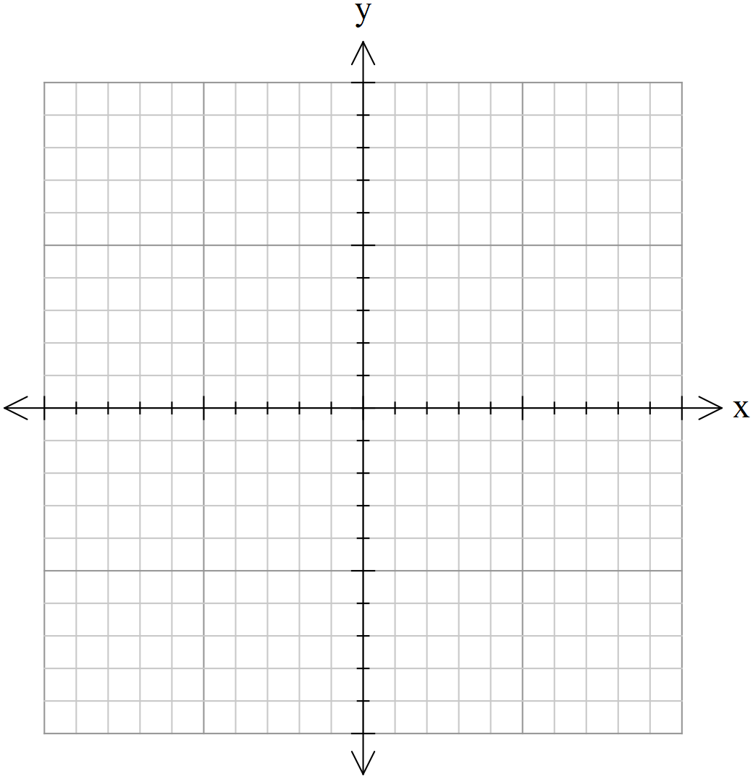
10
10
-10
-10
4. | [ 2 marks]  Write the linear equation for the following table of values:
x | 6 | 7 | 8 | 9 | 10 | 11
y | 8 | 10 | 12 | 14 | 16 | 18
5. | [ 5 marks: 2, 3]  Solve the following simultaneous equations:
a) y= 2x + 6
y + 3x = -4

b) 3x + 5y = -9
7x + 4y = 2

~ END OF TEST SECTION 1~

Name: ____________________________________ | Date:
SECTION 2: CALCULATOR ASSUMED

Time: | 37 minutes | Marks for Section 2: | 33 marks
Reading: | 2 minutes | Equipment Allowed: | ½ page notes(A4 one side), CAS calculator
Working: | 39 minutes

6. [ 5 marks: 1, 1, 3]
The value (V) of a car t years after it is purchased is given by the equation V = 350 – 80t.
- Find the value of the car when it was new

- After 5 years

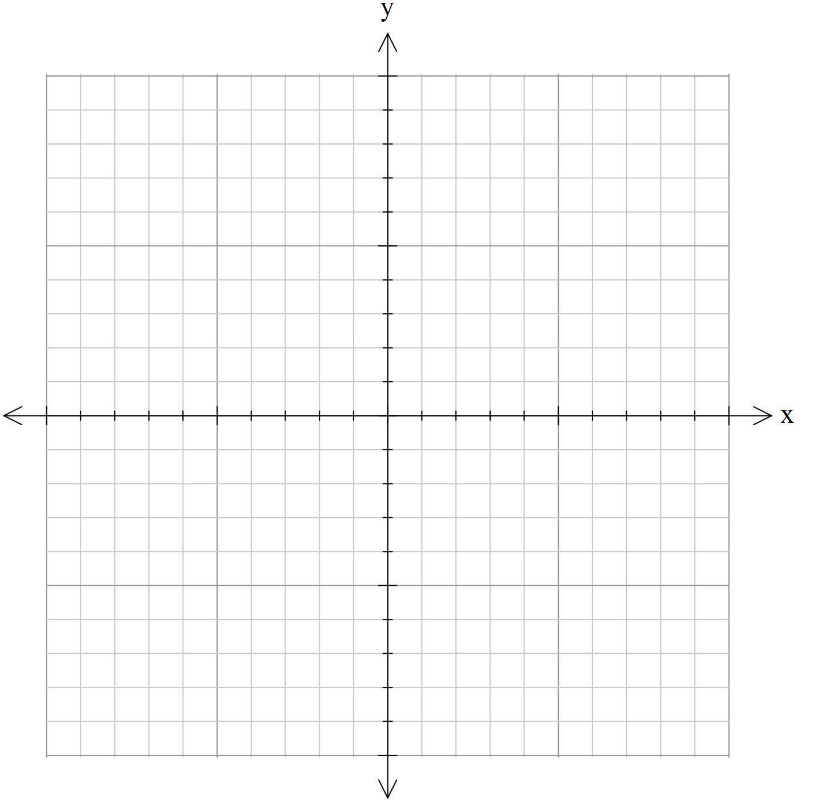
- Plot the relationship.

500

250

10
-10

-250

-500

7. [ 4 marks: 2, 2]
Find the equations of the line that passes through the points below:
a) | (-1, 3) and (0, 4) | b) | (-2, -2) and (0, 2)
8. [ 2 marks]
Find the equation of the line with a gradient of 6 that passes through the point (-1, 5)
9. [ 4 marks: 2, 2]
Find the equation of the lines from the following graph:
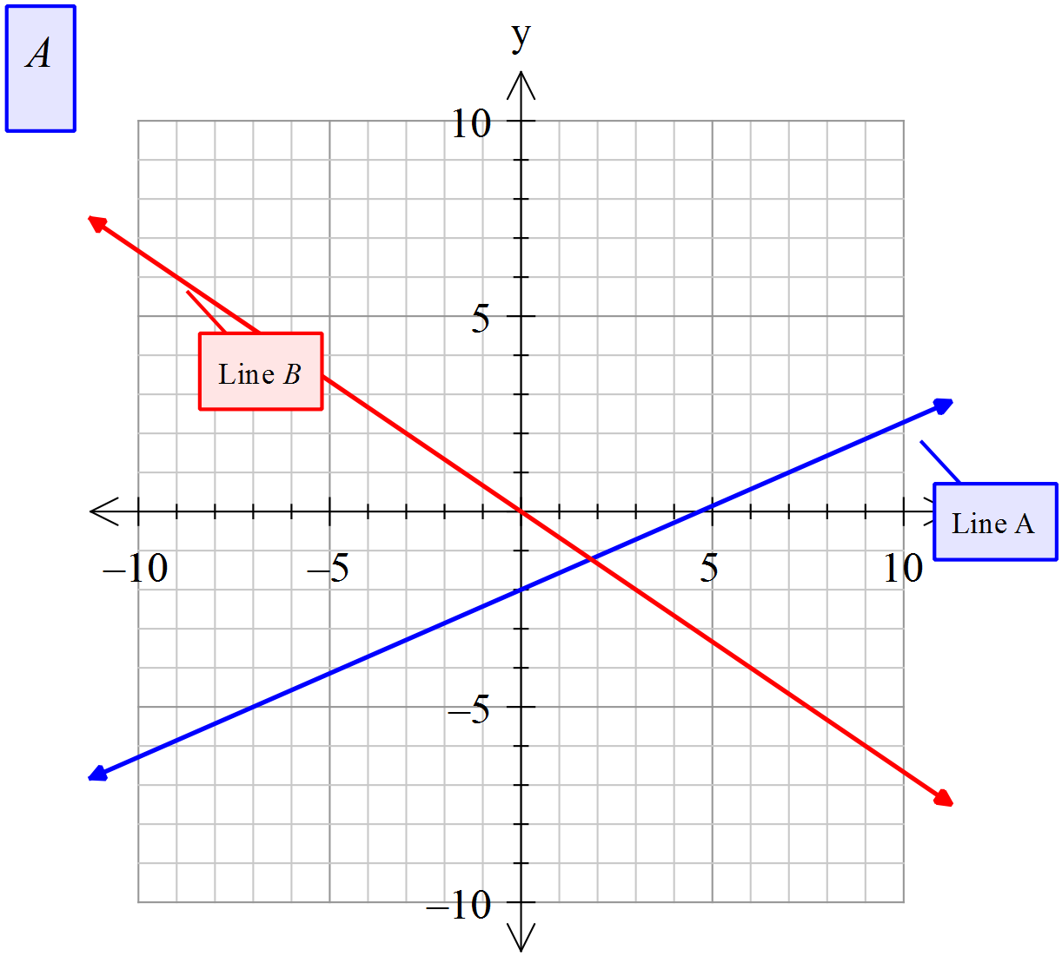
- Line A |  | - Line B

10. [ 3 marks: 2, 1]
The year 12’s are looking at transportation to their school ball. A hummer limo can carry 10 people, and a normal taxi can carry 2 people. There are 40 people that need transportation, and they need 8 vehicles for safety requirements.
a) Write the simultaneous equations for this information

b) Find the number of hummer limo’s and taxi’s they will need

11. [ 4 marks]
Graph the following step graph, showing the cost ($C) for the number of hours (n) spent in a car park:
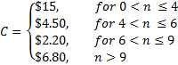
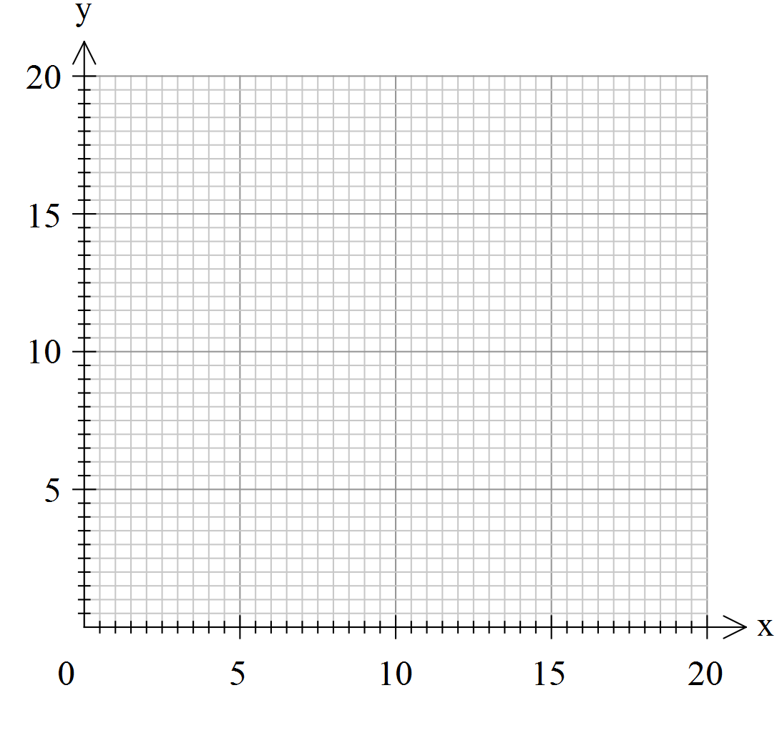
12. [11 marks: 2, 6, 3 ]
A real estate agent charges the following commission rates for selling property.
- 8% of the first $70 000 of the properties price
- 5% of the next $80 000
- 3.5% of the remaining amount
- Complete the table of values using the rates given above:
Property price ($P) | 0 | 70 000 | 150 000 | 800 000
Commission (C)
- Use the table above to help you draw a piecewise graph displaying the agents commission for property values from $0 to $800 000
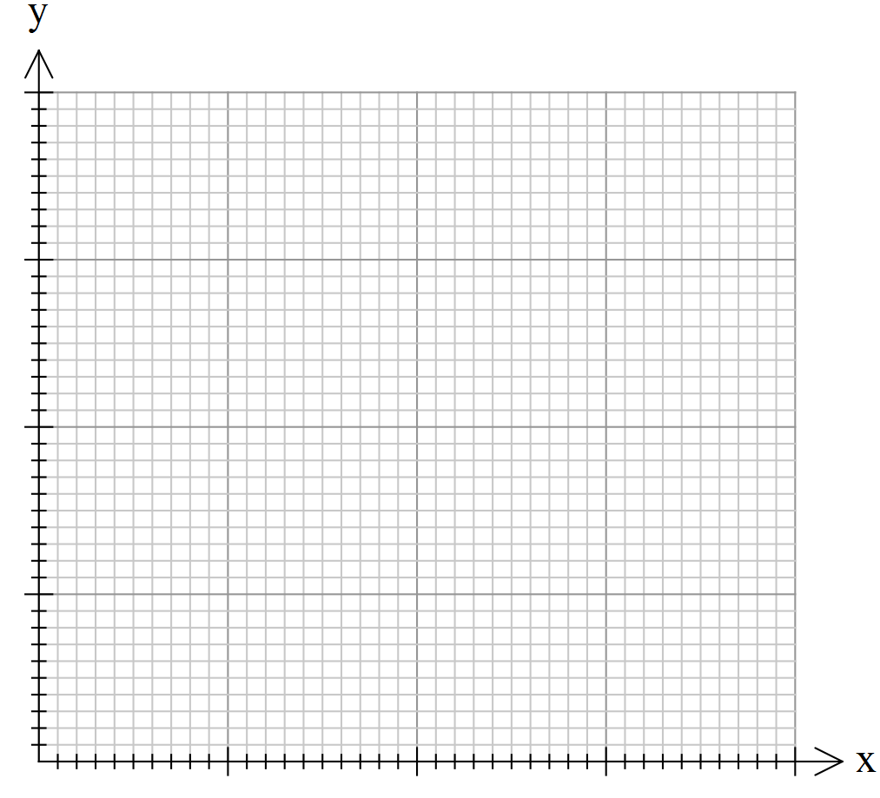
30 000
20 000
10 000
200 000
400 000
600 000
800 000
- Use the graph to find the commission earned for selling:
- A unit for $120 000
ii. A house for $400 000
iii. A farm house and land for $730 000
~ END OF TEST SECTION 2 ~

